Dasymetric Mapping of Village Crop Statistics to Parcel Level from X-band SAR

Crop type, health index and yield-to-date for 966 farms — ANRF AISEHack 2.0, Round 2
Team GDHTM — Yash Sorathiya · Jenish Sorathiya · Yajurshi Velani · Mahi Parmar · Aayush Pandya Study area: Sokhda village ( village_id 1), Vadodara district, Gujarat — 966 farm parcels
Data: four Capella X-band HH SLC acquisitions — 6 Jun, 19 Jun, 14 Aug, 13 Oct 2025 (kharif)

Summary
Every value in
submission.csv

is derived from the four provided Capella X-band scenes. Sentinel-1 and Sentinel-2 appear in

this project only as independent witnesses — they are used to test the product after it is built, and no optical or C-band measurement enters any shipped number. That separation is deliberate: it keeps the Capella imagery the primary source as the guidelines require, and it means our validation is genuinely independent rather than self-confirming.
One technique, applied twice. Everything we know about this village's crops, we know only in aggregate: the crop-area shares at village level, the yield anchor at district level. Nothing is known per farm — which is exactly what the brief asks for. Both quantities are therefore built the same way: hold the aggregate, and let the SAR supply only the variation inside it. Distributing a known total across finer units using an ancillary variable correlated with the true distribution is dasymetric mapping, and it is the spine of this pipeline.

known in aggregate | disaggregated to | ancillary variable from Capella
Round 1 village crop-area shares (MSE 11.071) | 966 parcel crop labels | per-farm soft evidence, area-constrained
Vadodara district yield (APY) | 966 parcel t/ha | completion × accumulation
Neither aggregate is error-free, and we do not treat them as such — the Round 1 shares are our own best estimate of the village mix, not ground truth. The argument for holding them is comparative, not absolute: the aggregate is estimated from a whole village of evidence, the per-farm label from one parcel of it, so the aggregate is by far the better-constrained of the two. §6 reports what that costs at farm level.
The health index has no aggregate to anchor to at all, so it is scored as a rank within crop rather than an absolute level — the same discipline applied to a quantity with no total to honour.
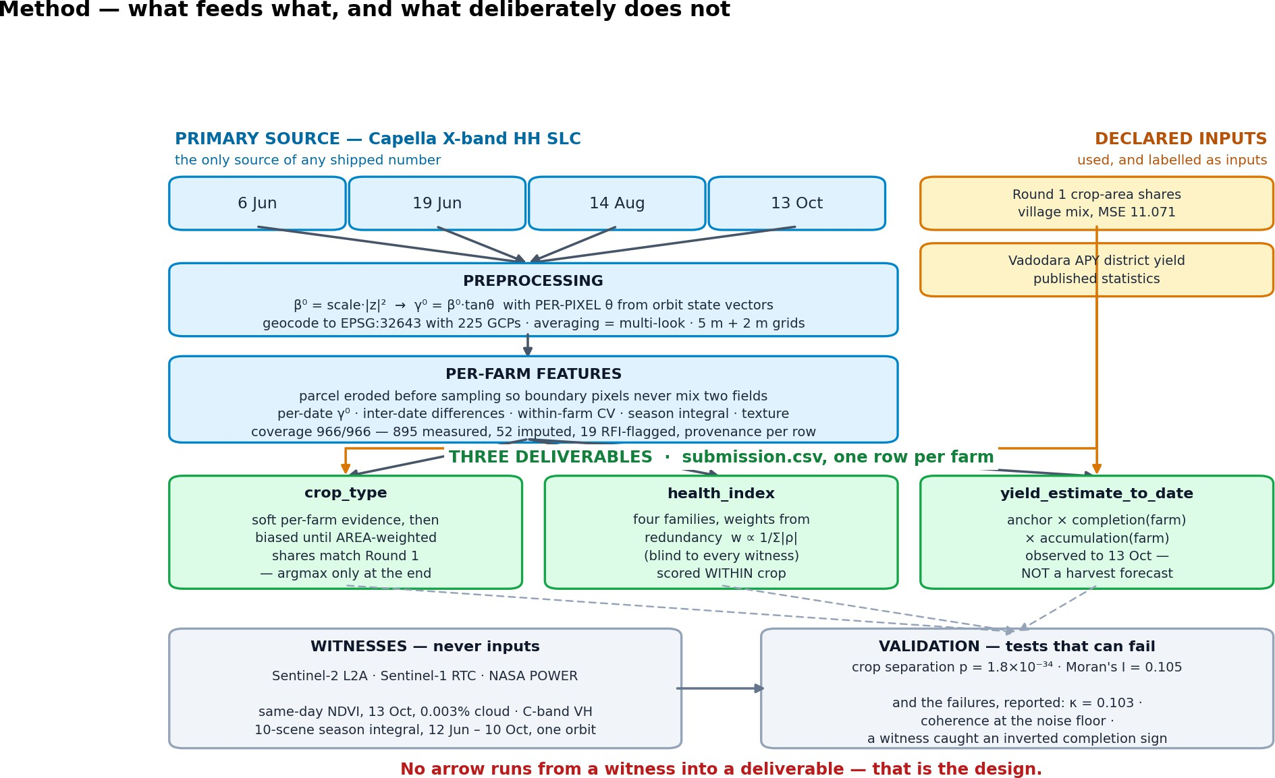
Figure 1. What feeds what. No arrow runs from a witness into a deliverable; auxiliary inputs that do feed the product are drawn in amber and labelled as inputs.
We report the checks that failed as prominently as those that passed. Three findings in §6 are negative, and one of them forced a sign correction in the shipped yield column.

Preprocessing workflow
Radiometry. Capella SLC pixels are complex. We form the brightness
𝛽0 = scale_factor ⋅ |𝑧|2
radiometry

following the product's own referenced
field ( beta_nought ) and the ESA EDAP guidance, then convert to the terrain-

𝛾⁰ = 𝛽⁰ ⋅ tan 𝜃

using a per-pixel incidence angle 𝜃. The angle field is reconstructed from the orbit state vectors rather than assumed constant across the scene; it agrees with the product metadata to 0.006°. Using γ⁰ rather than σ⁰ removes the first-order dependence on local geometry, which matters here because the four acquisitions span 28.7°–35.2° in incidence.

Geocoding. Slant range to EPSG:32643 using the 225 ground control points supplied with each product. Resampling is by averaging, which performs the multi-look in the same step and avoids a second interpolation. Two grids are produced: a 5 m base grid for per-farm statistics and a 2 m fine grid for texture.
Per-farm extraction. Each parcel is eroded before sampling so that boundary-straddling pixels do not mix two fields. Where erosion would empty a small parcel, a documented fallback ladder applies (erode → unbuffered → centroid). Coverage is complete: 966 of 966 farms carry a row — 895 measured directly, 52 filled by spatial nearest-neighbour imputation from adjacent farms of the same crop, and 19 flagged for radio-frequency interference. Every row carries its provenance in d4_debug.csv . Missing coverage is spatially clustered in the north-west rather than random, which is why imputation borrows from neighbours of the same crop instead of using a village mean.
Absolute calibration is not claimed. Our γ⁰ reads about +17 dB above the physically expected level. ESA's EDAP assessment notes that Capella's absolute accuracy is not declared while its relative accuracy is good — exactly the condition we observe. Every downstream quantity is therefore a difference between dates or a rank within a crop, never an absolute level. This is verified, not asserted: our between-farm spread on 13 Oct is 1.48 dB against the Sentinel-1 witness's 1.82 dB, so the contrasts survive even though the level does not.

Crop type — Round 1 applied to the new boundaries
Per-farm soft evidence is built from X-band features with a physical basis — the 19 June flood/double-bounce response for rice, August volume scattering for cotton, and the August-minus-June difference. These give per-farm class probabilities, which are then biased until the area-weighted argmax shares match the Round 1 shares exactly. Area weighting is used because the Round 1 quantity is an area share; weighting by farm count would satisfy the wrong constraint.
The justification is measured, not stylistic: in Round 1, free per-pixel assignment scored 5× worse than assigning nothing at all, so the village mix is honoured as a constraint rather than re-inferred.
One Round 1 signature was re-validated and imported. Testing all Round 1 feature signs against the Round 1 reconstruction, 13 of 15 agree, but Groundnut × NDVI-entropy significantly contradicts it (ρ −0.531, p = 0.003) — evidence that the tail of the Round 1 ladder partly fitted leaderboard noise. Only the rice August-minus-June signature cleared all four of our transfer tests and was shipped. That a Round 1 feature can be contradicted at all is the reason we treat the shares as an estimate.

Crop health index
The index combines four families, each z-scored across farms:

family | measurement | rationale
level | August γ⁰ | peak canopy volume
growth | 14 Aug − 19 Jun | the only geometry-matched date pair (0.076° apart)
uniform | −(within-farm CV) | a patchy stand means gaps, waterlogging or pest damage
persist | season integral | canopy held across the season, not on one lucky date
Weights are derived, not chosen. Each family's weight is inversely proportional to its total absolute correlation with the others,
growth
uniform
persist
level

𝑤_{𝑘} ∝ 1/ ∑𝑗 |𝜌 ( 𝑘, 𝑗 ) |, giving
0.283,
0.301,
0.228,
0.189. The rule reads only the feature

matrix and is blind to every witness by construction — weights tuned by watching NDVI would convert a held-out check into a fitting target. Notably, this blind rule outperformed every hand-tuned variant we tried.
Scored within crop. Cotton and groundnut differ by roughly 4 dB for reasons unrelated to health, so a pooled score would largely re-measure crop type. Each farm is scored against its own crop's median, so 50 means "typical for this crop", and the score is a bounded transform of a robust z-score rather than a percentile rank, which preserves the size of a difference instead of flattening it to a rank.
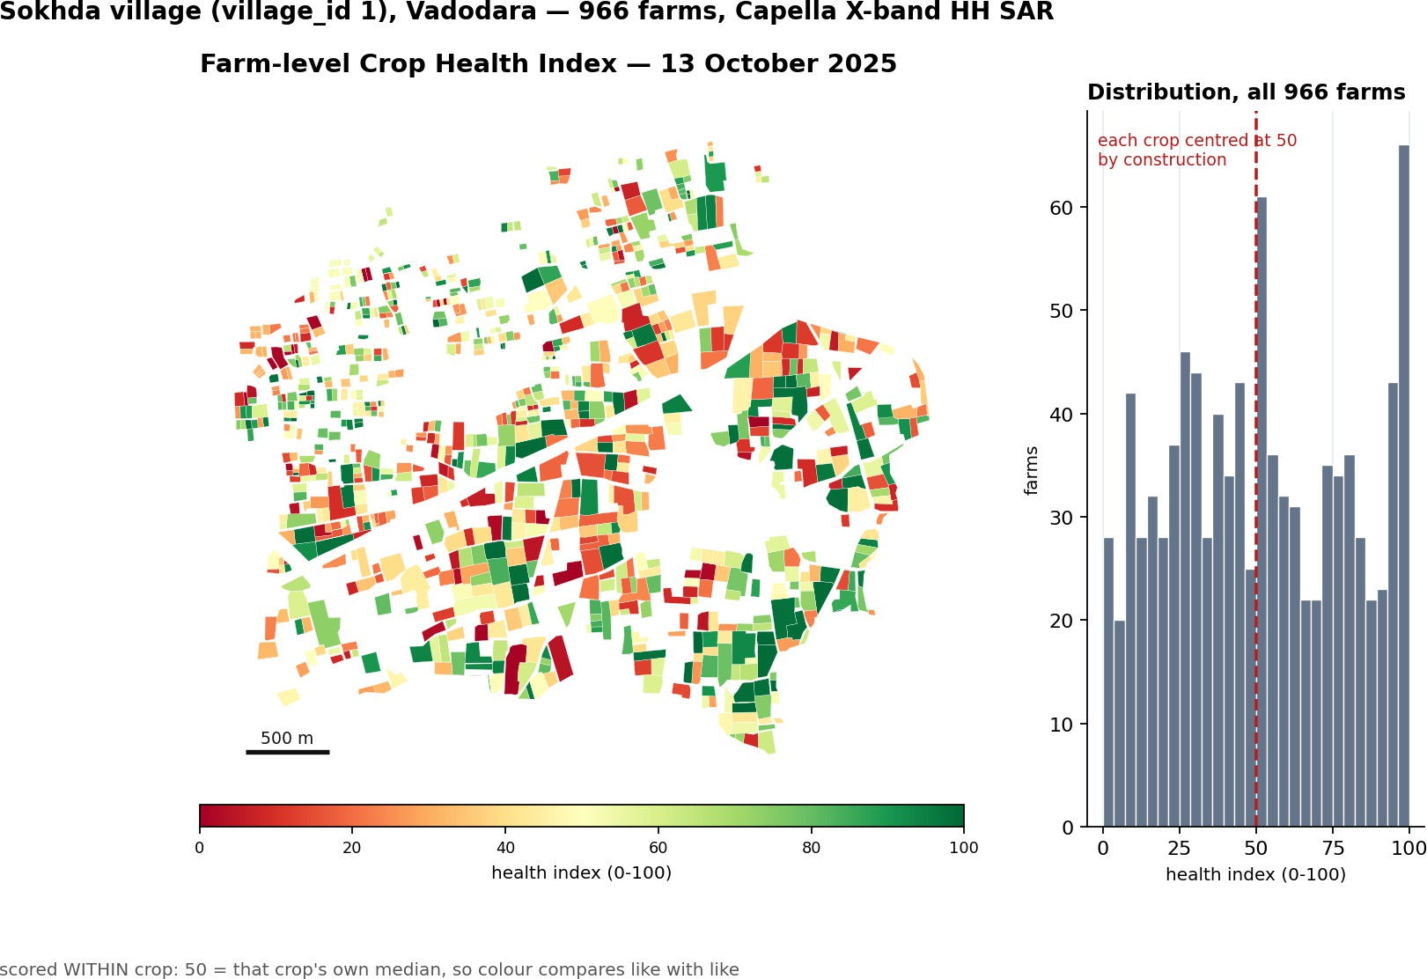

Figure 2. Farm-level Crop Health Index, 13 October 2025. Within-crop scoring centres every crop at 50 by construction; the histogram states this rather than letting it read as a result.

Yield to date

yield_to_date [t/ha] =
˛a_n_c_h_o_r_d_is_tr_i¸ct level, from statistics
× ˛c_o_mp_l_e_t_ion_farm × a_c_c_u_mulati_o_nfa_r¸m

variation, measured from SAR

We read the column exactly as the brief defines it — "the estimated yield potential up to the final acquisition date using all available temporal observations", and explicitly not a final harvest forecast. Values are therefore scaled by season completion (Cotton 0.45, Groundnut 0.75, Rice/Maize/Bajra 0.95) and are never projected forward; dividing by that factor recovers a full-season figure. Cotton reads low per hectare (median 0.34 t/ha) because on 13 October it is only about 45% through picking, and because the anchor is lint rather than seed cotton.
This is the second dasymetric step: the level is the district anchor and the variation is measured. We state that split rather than blur it — SAR cannot measure absolute yield without calibration data, and pretending otherwise would be the least defensible claim in this project. Both per-farm terms are measured, not assumed: completion from each farm's own August→October change, and accumulation from the season integral, which uses all four acquisitions.
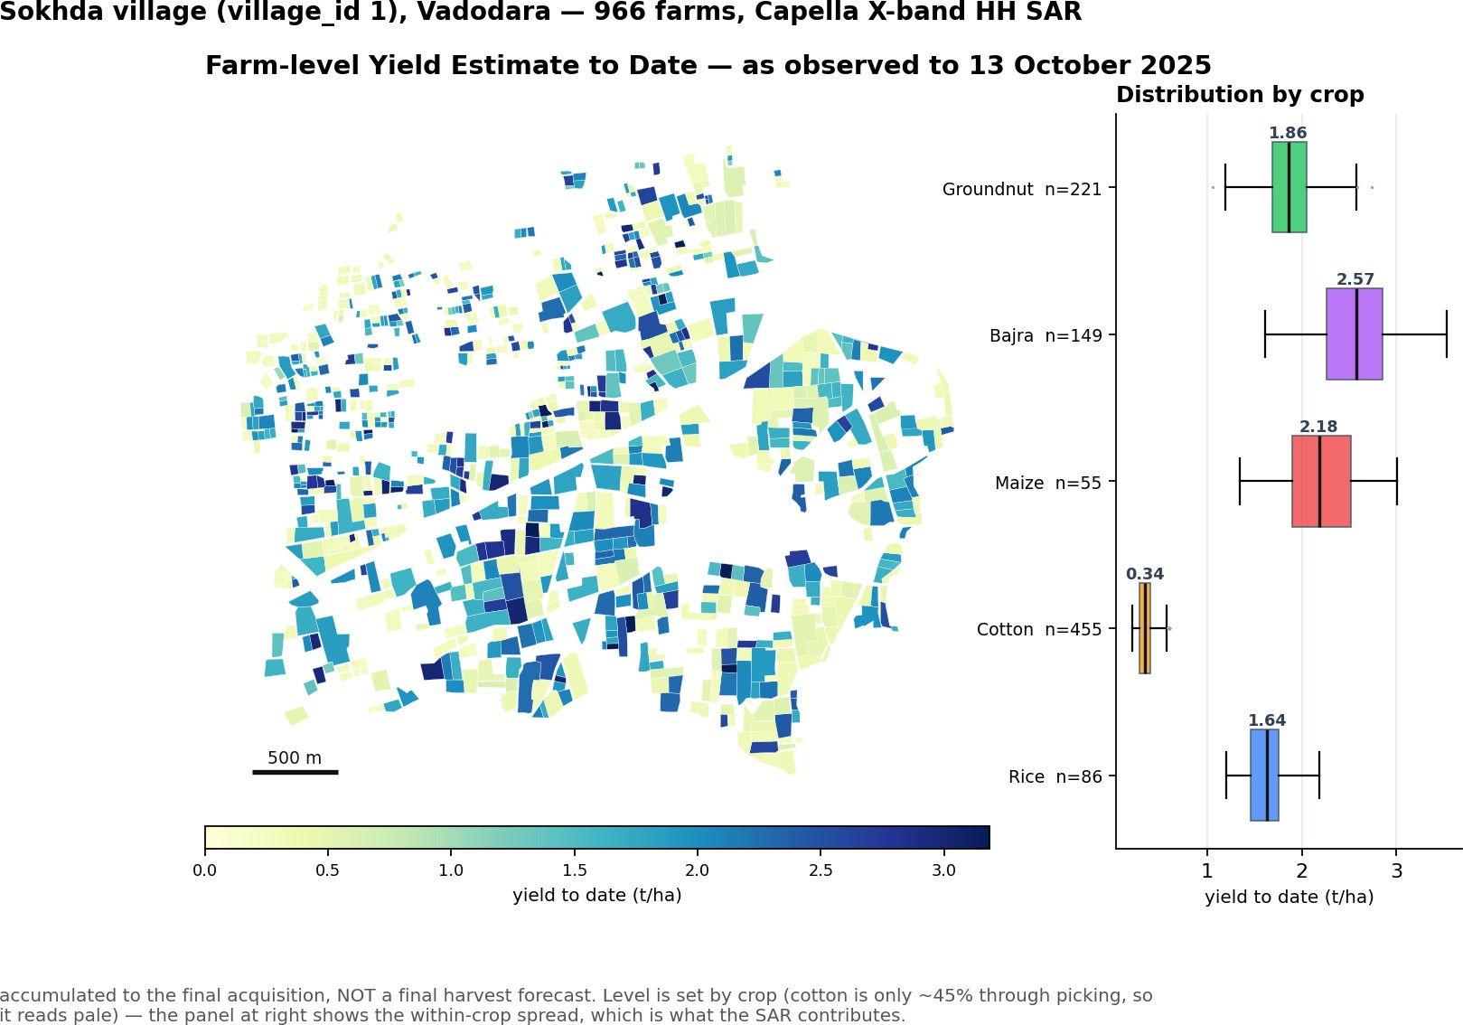
Figure 3. Farm-level Yield Estimate to Date. Cotton reads pale because on 13 October it is only ~45% through picking; the level is set by crop and the SAR contributes the within-crop spread.

External datasets, and what they were used for

dataset | access | role
Sentinel-2 L2A | Microsoft Planetary Computer, open | witness only — same-day, 13 Oct, 0.003% cloud
Sentinel-1 RTC | Microsoft Planetary Computer, open | witness only — single date and 10-scene season integral
NASA POWER | open | rainfall context for the acquisition dates
Vadodara APY statistics | published government statistics | yield level anchor (an input, and declared as one)
Gujarat DCS parcel registry | open government WFS | survey numbers for 947/966 farms, for future field validation
No paid or restricted dataset was used. Nothing in the first two rows enters submission.csv .

Key findings
The crop classes separate on two sensors they never saw. Kruskal–Wallis p = 1.8×10⁻³⁴ on Sentinel-2 NDVI and 7.7×10⁻²⁰ on Sentinel-1 VH. The ordering is the result, not the p-value: on 13 October cotton is the only crop still standing and tops both witnesses, while maize is harvested and bottoms both — the crop calendar, recovered independently.
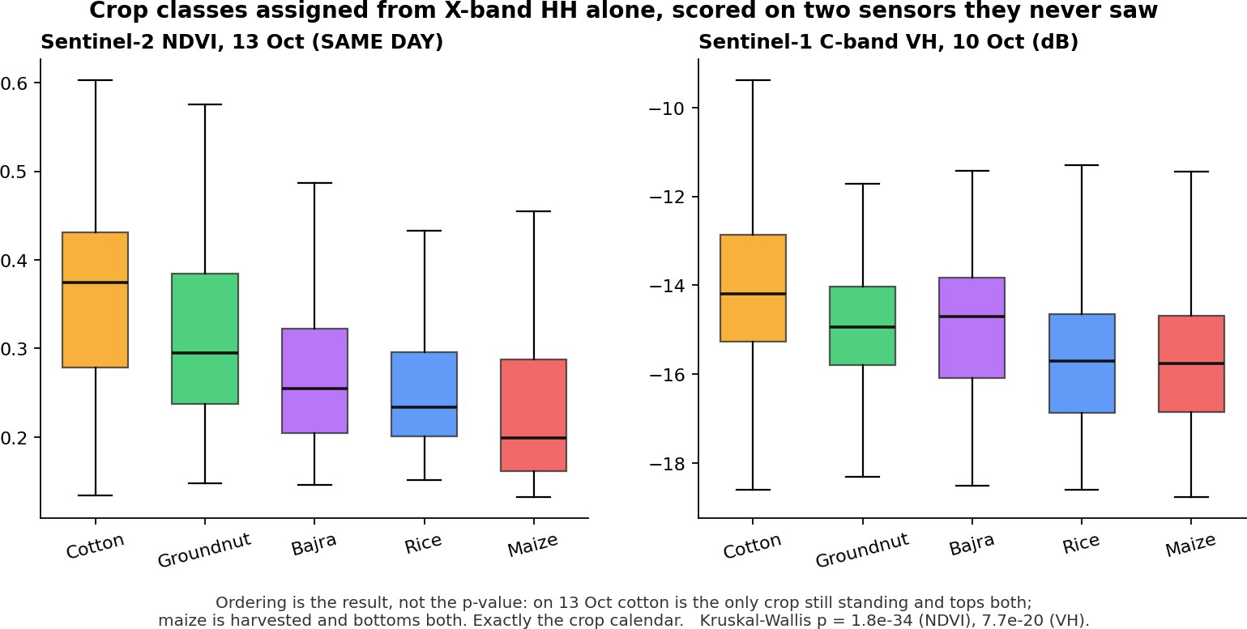

Figure 4. The independent witnesses. Both panels are sensors the pipeline never read: the crop classes separate on Sentinel-2 NDVI and Sentinel-1 VH, and the ordering matches the kharif calendar — cotton still standing on 13 October, maize already harvested.
Health clusters spatially far beyond chance. Moran's I = 0.105 against a 199-permutation null. Neighbouring fields share soil, water and management; modelling noise would not cluster.
The yield accumulation term now has a witness of the right shape. spans 12 Jun to 13 Oct, but both
season_integral
original witnesses were single instants. Cumulative NDVI — the textbook fix — is impossible here: Sokhda had zero Sentinel-2 scenes under 20% cloud in June, July, August or September. We therefore built a season-integrated witness from the sensor that did observe that period: 10 Sentinel-1 scenes, 12 Jun–10 Oct, all one relative orbit, integrated by the same trapezoid. It corroborates cotton (ρ +0.305, p = 5×10⁻¹⁰) and rice (+0.290, p = 0.007), is null for maize and groundnut, and contradicts bajra (−0.219, p = 0.008).
Village aggregate. 447.5 ha, 595 t accumulated to 13 October. Aggregation is area-weighted,
village production [t] = ∑ (yieldfarm [t/ha] × area_{farm} [ha])
farms
never a mean of per-hectare rates.

What failed, reported as failures
  - Per-farm crop labels do not survive an independent rebuild. Against a Sentinel-2 + Sentinel-1 map, Cohen's κ =
+0.103 — negligible. Cotton is the one class both methods find. The village mix is well constrained; the per-farm label is not, and we say so.
  - Repeat-pass coherence (19 Jun × 14 Aug) sits at the noise floor. The stable-scatterer control failed to clear its own bias floor, so we cannot separate true decorrelation from our own limitation, and claim neither.
  - A sign error in the completion term, caught by a witness. We had assumed a harvested field brightens toward bare soil. Sentinel-2 disagreed in all five crops, so the term was reading standing crop as senescence. The sign was corrected and the shipped column changed.
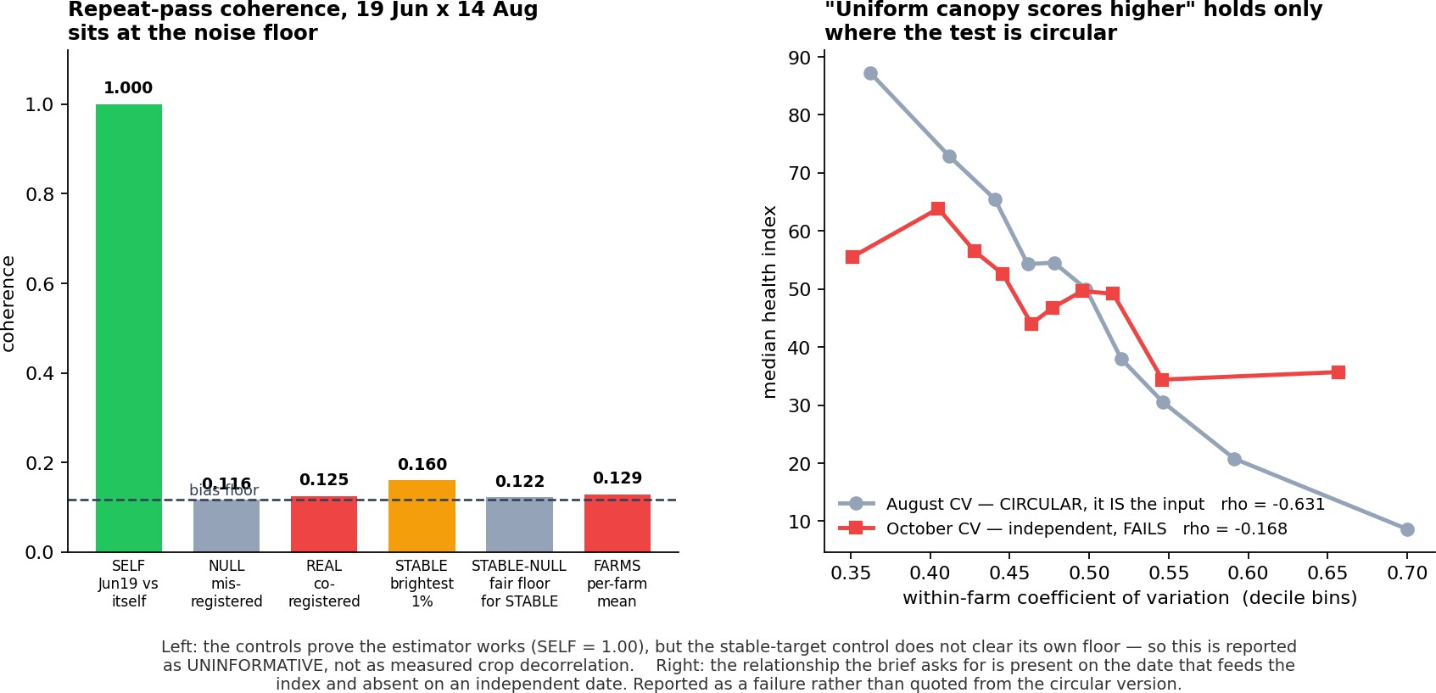
Figure 5. Two results we report as failures: repeat-pass coherence does not clear its own control floor, and the uniformity-health relationship holds on the date that feeds the index but fails on an independent date.

What the negatives imply for use
The three failures above are not symmetric in consequence, so we state what each one licenses. The κ result means this product should be read at village and crop-group level, which is the level the aggregation table reports and the level Round 1 was scored at; a single farm's label should not be acted on alone. The coherence result costs us nothing shipped — no submitted column depends on it — but it does close off change detection as a route we could have claimed. The bajra contradiction is the one that would change a decision: bajra is 15% of the parcels and its season-integral term runs against the witness, so its yield column carries the weakest support of the five crops. We leave the value in rather than tune it, and flag it here, because the constraint that produced it — the Round 1 area shares — is estimated from far more evidence than a single witness correction would be, so we do not overwrite it on one contradicting signal.

Reproducibility
notebooks/I9_pipeline.ipynb runs from a fresh kernel and its final cell asserts that it reproduces the shipped submission.csv exactly. A 19-check ship gate verifies schema, value ranges, units and deliverables, and a separate gate asserts that every number quoted in this report matches the shipped artefacts, so the prose cannot drift from the data.

